**­­**

**­­­­­­­**

**LAB # 08**

|  |  |
| --- | --- |
| **SUBMITTED TO­** | **­­­Esha E Noor Durrani** |
| **SUBMITTED BY** | **Muhammad Ayaan Farrukh** |
| **REGISTRATION NO.** | **B24F0488CS035** |

**­**

# **LAB TASK # 01:**

**Write question here.**

Write a program to initialize a 1D array with 5 elements and print them.

**SOURCE CODE:**

|  |
| --- |
| #include<iostream>  using namespace std;  int main()  {      int arr[5]={25,23,62,5,98};      for(int i = 0; i<5; i++)      {          cout<<arr[i]<<"\n";      }  } |

**OUTPUT:**

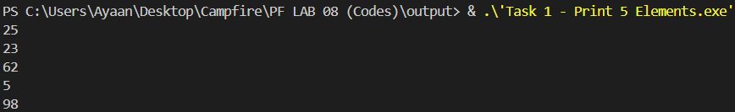

# **LAB TASK # 02:**

­­­­ **Write question here.**

Write a program to find the maximum element in a 1D array.

**SOURCE CODE:**

|  |
| --- |
| #include<iostream>  using namespace std;  int main()  {      int max = 0;      int arr[5]={67,79,99,89,97};      for(int i = 0; i < 5; i++)      {          if(arr[i] > max){              max = arr[i];          }      }      cout<<max;  } |

**OUTPUT:**



# **LAB TASK # 03:**

­­­­ **Write question here.**

Write a program to find the sum of elements at even indices (0, 2, 4, ...) in a 1D array.

**SOURCE CODE:**

|  |
| --- |
| #include<iostream>  using namespace std;  int main()  {      int sum = 0;      int arr[6]={5,10,15,20,25,30};      for(int i = 0; i < 6; i += 2){          sum += arr[i];      }      cout<<"Sum of Even Indexed Element is: "<< sum;  } |

**OUTPUT:**

